Physics Stage 3: STAWA Set 5 Answers

1. m N stands for metres Newton or more usually, N m (force each metre)
mN stands for milli Newtons or 10⁻³ N.

2 F = 160 N  r = 750 mm = 0.750 m  M = ? | M = F r  M = 160 x 0.750  M = 120 N m

Torque applied = 120 N m

3 M = 88 N m  r = 400 mm = 0.400 m  F = ? | M = F r  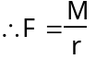  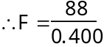  F = 220 N

Force needed = 220 N

4 In a truck or bus more torque (turning moment) is needed to turn the wheels. The same force on a larger diameter steering wheel will provide a greater turning moment than on a smaller steering wheel since M α r. Racing cars have a smaller steering wheel that gives more direct steering. This means that a smaller movement of the steering causes a greater amount of turning in the car, although a larger force is needed.

5 The centre of mass of the hiker plus backpack should be directly over his feet. If Michael stands upright the backpack's weight will cause a backwards torque and topple Michael onto his back.
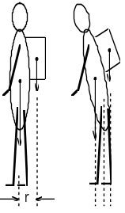

6 | 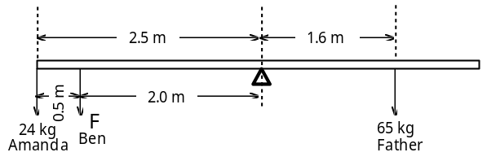

For see-saw to balance
Σ acm = Σ cm where M = F r
in this case Σ acm = 24 x 9.8 x 2.5 = 588 N m
and Σ cm = 65 x 9.8 x 1.5 = 1019.2 N m
So the see-saw will begin to rotate clockwise in the direction of the father.
For equilibrium Σ acm = Σ cm
588 + F x 2 = 1019.2
F = 215.6 N

and mass of Ben = 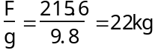

Ben's mass = 22 kg

7 If the wheel's radius is reduced, the torque arm from the axle to the road is reduced and a greater force is transferred to the road. A larger acceleration is achieved at the expense of a lower top speed even though the speedometer will show higher readings than is actually being achieved.

8 a | 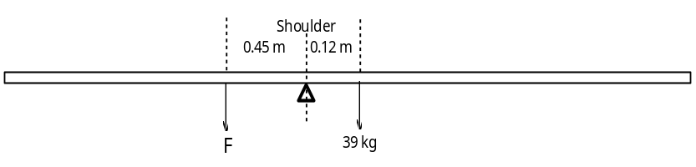

Take moments about plumber's shoulder
Σ acm = Σ cm where M = F r
F x 0.45 = 36 x 9.8 x 0.12
F = 94.08 N

So downwards force = 94 N

- Upwards force is total force so 94.08 + (36 x 9.8)
Total force = 446.88 N

So upwards force = 447 N

9 | 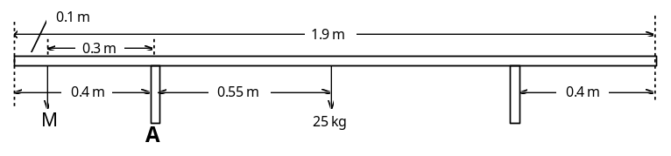

Take moments about leg A
Σ acm = Σ cm where M = F r
M x 9.8 x 0.3 = 25 x 9.8 x 0.55
F = 45.83 kg

Maximum mass of person = 46 kg

10 | 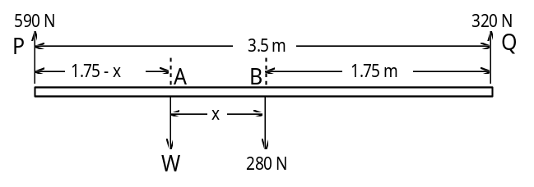

Σ F up = Σ F down
590 + 320 = W + 280
W = 630 N

a John's weight = 630 N

Take moments about B OR  Σ acm = Σ cm  630 x x + 320 x 1.75 = 590 x 1.75  630 x = 472.5  x = 0.75 m | Take moments about A  Σ acm = Σ cm  320 x (1.75 + x) = 590 x (1.75 - x) + 280 x x  560 + 320 x = 1032.5 - 590 x + 280 x  630 x = 472.5  x = 0.75 m
b John is standing 0.75 m from the centre towards P

11 | 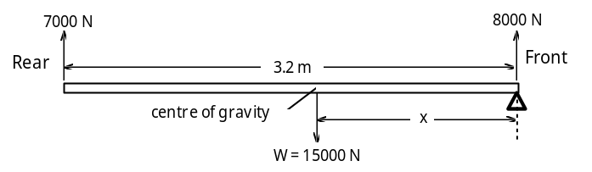

Σ F up = Σ F down  7000 + 8000 = W  Weight of car = 15000 N | Take moments about front wheels  Σ acm = Σ cm where M = F r  15000 x x = 7000 x 3.2  x = 1.493 m

Centre of gravity of car is 1.5 m from front wheels

12 | 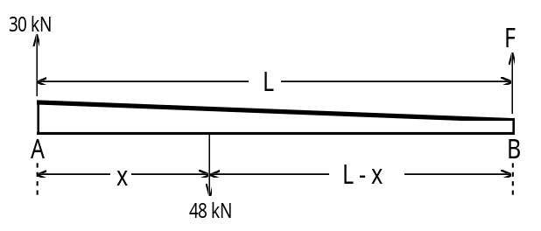

Second lifting operation F = 48 kN - 30 kN = 18 kN

a Force in second operation = 18 kN

Take moments about B, and let the length of the tree trunk be L
Σ acm = Σ cm where M = F r
48000 (L - x) = 30000 x L
48000 L - 48000 x = 30000 x L
x = 0.375 L

b Centre of mass is 0.375 L from the heavy end

Alternative method for part a
Take moments about A
Σ acm = Σ cm
F x L = 48000 x x
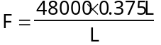
F = 18000 N

a Force in second operation = 18 kN

13  Car is moving away from viewer | 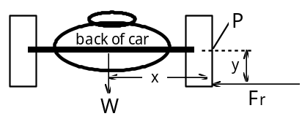
When the car is turning to the left there is a large frictional force applied at the base of the right hand wheel. Fr creates a clockwise torque about P tending to roll the car. The weight force creates a stabilising anticlockwise torque about P. While cornering we want the anticlockwise torque to remain larger than the clockwise torque. This is achieved by reducing the moment arm y and increasing the moment arm x. This is done by lowering the centre of mass of the car and increasing the wheel base.

14 | 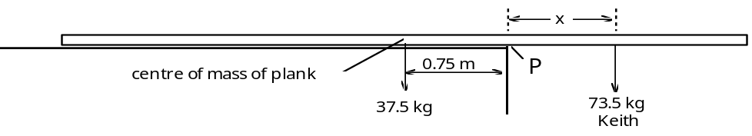

Take moments about P
Σ cm = Σ acm where M = F r
73.5 x 9.8 x x = 37.5 x 9.8 x 0.75
x = 0.383 m

a Keith can stand up to 383 mm from the balcony edge

b By allowing less overhang of the plank Keith can stand further from the edge. This is because the centre of mass of the plank will be further in from the edge and will create a greater stabilising torque about the balcony edge. Alternatively, Keith could stack heavy objects on the plank as far as possible towards the opposite end from which he is working.

15 | 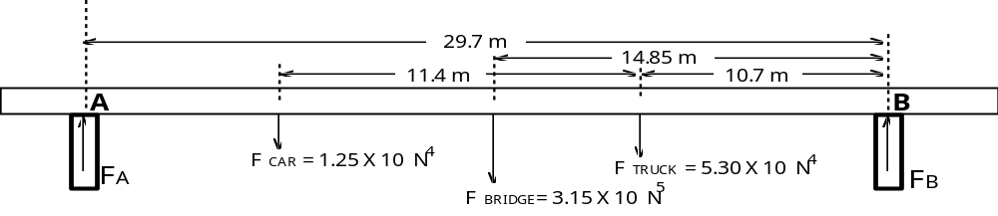

Total weight of bridge plus vehicles = 3.805 x 105 N

Take moments about pier B where M = F r
Σ cm = Σ acm
FA x 29.7 = 1.25 x 104 (11.4 + 10.7) + 3.15 x 105 x 14.85 + 5.3 x 104 x 10.7
FA = 1.859 x 105 N

for equilibrium Σ F up = Σ F down
FA + FB = 3.805 x 105
1.859 x 105 + FB = 3.805 x 105
FB = 1.946 x 105 N

Weight supported by pier A = 1.86 x 105 N
Weight supported by pier B = 1.95 x 105 N

16 | 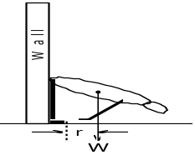 | As you bend over your centre of mass moves forward so that your weight force creates a turning moment about your toes with a moment arm r. As a result you will fall forward.  When you try this away from the wall your legs are angled backwards as your hips move back and your centre of mass remains over your feet.

16 Besides your arms not having the muscle strength of your legs, your hands on the ground have limited ability to counteract unbalanced torques about the end of your forearm. When standing your weight force on your foot acts forward of your heel and the tension in the calcanean tendon adjusts to counteract unbalanced torques produced as your centre of mass moves slightly forwards or backwards.

18 | 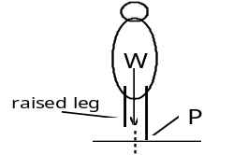

When standing still your weight is distributed evenly over both of your feet as your weight force acts down through a vertical line somewhere between each foot. As you take a step and you raise your leg to move it forward your weight force creates an unbalanced turning moment about your other foot at P. To stop this effect we lean to one side and transfer our weight momentarily over just one foot. When we do this the line of action of our weight force acts through our grounded foot and does not produce an unbalanced moment. The reverse happens as we take the next step causing us to sway to the other side.

19 As the hurdler strides over the hurdle, the front leg is raised causing the centre of mass to move higher. Leaning forward helps keep the hurdler's centre of mass as low as possible while clearing the hurdle so that less energy is used in raising the centre of mass over the hurdle.

20
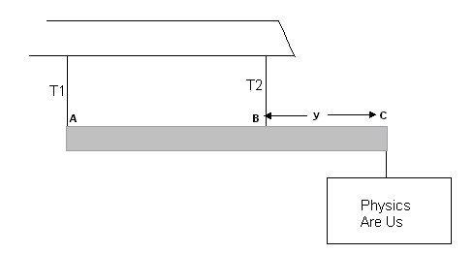

Force up = Force down (resolve vertically)
110 + 260 = (30 x 9.8) + (sign x 9.8)
370 = 294 + (sign x 9.8)
Sign = 76 ÷ 9.8
mass sign = 7.76 kg

Take moments about A,
ΣCM = ΣACM
(1.5 x 30 x 9.8) + (3 x 76) = 260(3 – y)
441 + 228 = 780 – 260y
-111 = -260y
y = 0.427 m
3 – 0.427 = 2.57 m
so 2.57 m from point A.

21 Find the distance y.

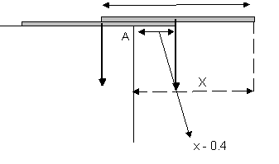
Take moments about the table corner, A.
(m x 9.8) x (x - 0.4) = (m x 9.8) x (0.8 - x)
9.8m x (x – 0.4) = 9.8m x (0.8 - x)
cancel 9.8m
x – 0.4 = 0.8 – x
2x = 1.2
y = 0.6 m

Note: This can be done by symmetry ( ¾ can hang over)

